32.4: a) 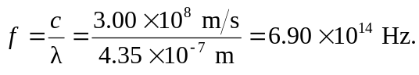
b) 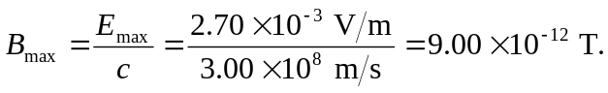

c) The electric field is in the -direction, and the wave is propagating in the −z-direction. So the magnetic field is in the −y-direction, since 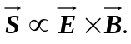Thus:

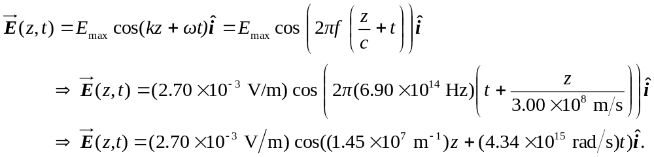

And

